22.27: a) 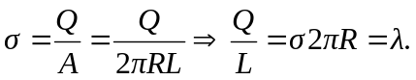
b) 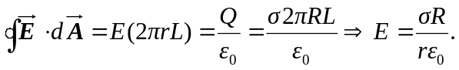
c) But from (a), 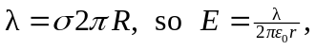 same as an infinite line of charge.

